CO1-AT-3- SCENARIO BASED QUESTIONS
Name: Ramya Y
Register Name: 192424397
Course Code: DSA0404
Course Name: Fundamentals of Data Science

- Scenario: You are working on a project that involves analyzing a dataset containing information about houses in a neighborhood. The dataset is stored in a CSV file, and you have imported it into a NumPy array named house_data. Each row of the array represents a house, and the columns contain various features such as the number of bedrooms, square footage, and sale price.
Question: Using NumPy arrays and operations, how would you find the average sale price of houses with more than four bedrooms in the neighborhood?
House_ID | Bedrooms | Sqft | Sale_Price
H1 | 3 | 1400 | 7500000
H2 | 5 | 2200 | 12500000
H3 | 4 | 1800 | 9800000
H4 | 6 | 3000 | 18500000
H5 | 2 | 1100 | 5200000
Ans:
Code:
import numpy as np
house_data = np.array([
[3, 1400, 7500000],
[5, 2200, 12500000],
[4, 1800, 9800000],
[6, 3000, 18500000],
[2, 1100, 5200000]
])
filtered = house_data[house_data[:, 0] > 4]
average_price = np.mean(filtered[:, 2])
print("Average Sale Price:", average_price)
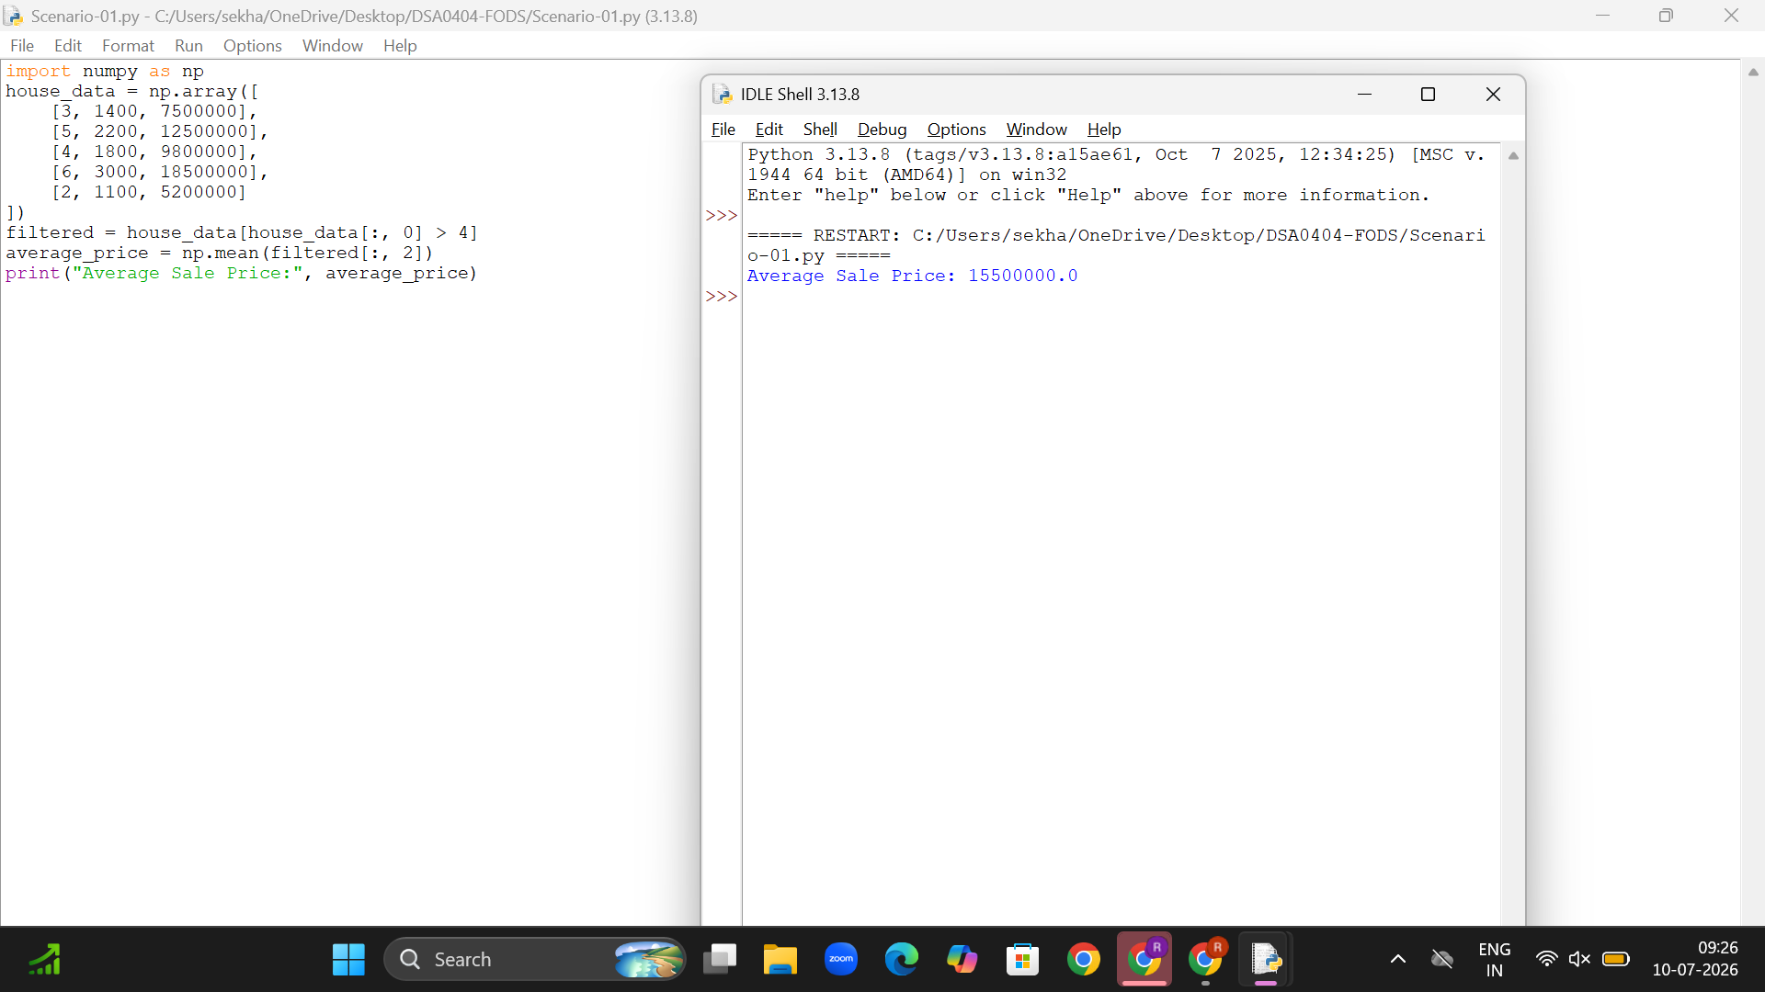

- Scenario: An email service provider wants to automatically classify incoming emails as spam or non-spam. Each email is represented using features such as number of links, number of capitalized words, and total email length. Historical email data is labeled as spam (1) or not spam (0).
Question:
Develop a Logistic Regression model using the given features.
Predict whether a newly received email is spam or not.
Email_ID | Num_Links | Num_Caps_Words | Email_Length | Spam
E1 | 1 | 3 | 120 | 0
E2 | 6 | 15 | 300 | 1
E3 | 0 | 1 | 80 | 0
E4 | 4 | 10 | 250 | 1
E5 | 2 | 5 | 160 | 0

Ans:
Code:
import numpy as np
from sklearn.linear_model import LogisticRegression
X = np.array([
[1, 3, 120],
[6, 15, 300],
[0, 1, 80],
[4, 10, 250],
[2, 5, 160]
])
y = np.array([0, 1, 0, 1, 0])
model = LogisticRegression()
model.fit(X, y)
links = int(input("Enter Number of Links: "))
caps = int(input("Enter Number of Capitalized Words: "))
length = int(input("Enter Email Length: "))
new_email = np.array([[links, caps, length]])
prediction = model.predict(new_email)
if prediction[0] == 1:
print("Prediction: Spam Email")
else:
print("Prediction: Not Spam")
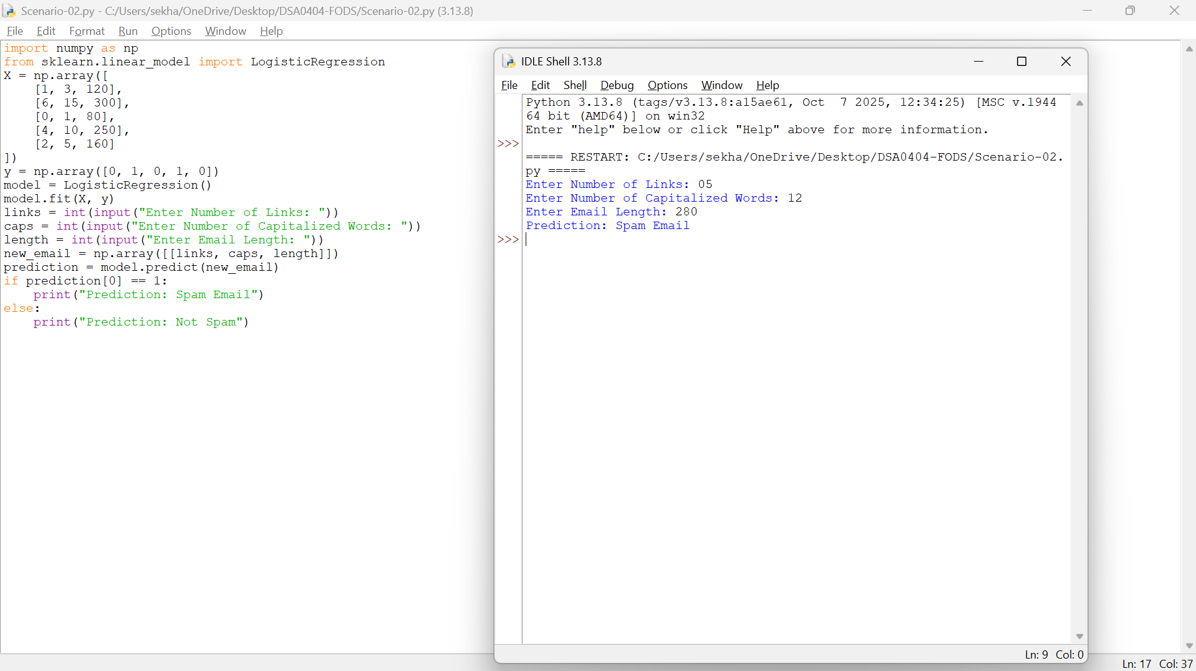

- Scenario: An email service provider wants to automatically classify incoming emails as spam or non-spam.Each email is represented using features such as number of links, number of capitalized words, and total email length. Historical email data is labeled as spam (1) or not spam (0).
Question:
Develop a Logistic Regression model using the given features.
Predict whether a newly received email is spam or not.
Email_ID | Num_Links | Num_Caps_Words | Email_Length | Spam
E1 | 1 | 3 | 120 | 0
E2 | 6 | 15 | 300 | 1
E3 | 0 | 1 | 80 | 0
E4 | 4 | 10 | 250 | 1
E5 | 2 | 5 | 160 | 0

Ans:
Code:
import numpy as np
from sklearn.linear_model import LogisticRegression
X = np.array([
[1, 3, 120],
[6, 15, 300],
[0, 1, 80],
[4, 10, 250],
[2, 5, 160]
])
y = np.array([0, 1, 0, 1, 0])
model = LogisticRegression()
model.fit(X, y)
new_email = np.array([[3, 8, 200]])
prediction = model.predict(new_email)
print("Prediction:", prediction[0])
if prediction[0] == 1:
print("Spam Email")
else:
print("Not Spam")

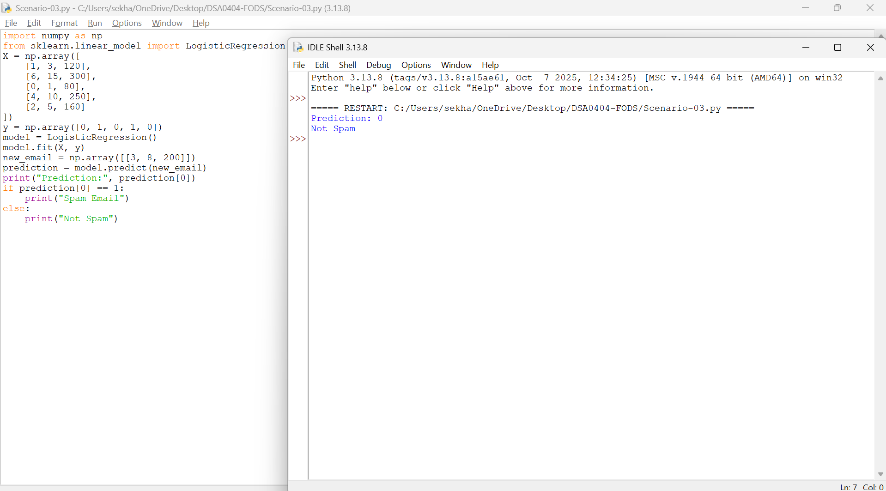

- Scenario: Linear Regression for Car Resale Price PredictionYou are a data analyst at a used-car marketplace. You want to predict the resale price of a car based on features such as car age (years), total kilometers driven, and engine capacity (cc). You have a dataset containing past car listings with these features and their final selling prices.
Question: Write a Python program that loads the dataset containing Age, Kms_Driven, Engine_CC, and Resale_Price, trains a Linear Regression model using scikit-learn, accepts user input for a new car, and predicts the estimated resale price.
Car_ID | Age (Years) | Kms_Driven | Engine_CC | Resale_Price
C1 | 2 | 25000 | 1200 | 650000
C2 | 5 | 60000 | 1500 | 420000
C3 | 3 | 40000 | 1300 | 520000
C4 | 7 | 90000 | 1800 | 300000
C5 | 1 | 15000 | 1000 | 720000
Ans:
Code:
import pandas as pd
from sklearn.preprocessing import LabelEncoder
from sklearn.linear_model import LinearRegression
data = {
"Brand": ["Maruti", "Hyundai", "Honda", "Toyota", "Tata"],
"Kms_Driven": [25000, 60000, 40000, 90000, 15000],
"Engine_CC": [1200, 1500, 1300, 1800, 1000],
"Resale_Price": [650000, 420000, 520000, 300000, 720000]
}
df = pd.DataFrame(data)
label_encoder = LabelEncoder()
df["Brand"] = label_encoder.fit_transform(df["Brand"])
X = df[["Brand", "Kms_Driven", "Engine_CC"]]
y = df["Resale_Price"]
model = LinearRegression()
model.fit(X, y)
print("Available Brands:")
brands = label_encoder.classes_
for i, brand in enumerate(brands):
print(i, "-", brand)
brand_name = input("\nEnter Brand Name: ")
kms = int(input("Enter Kilometers Driven: "))
engine = int(input("Enter Engine CC: "))
brand_code = label_encoder.transform([brand_name])[0]
new_car = [[brand_code, kms, engine]]
predicted_price = model.predict(new_car)
print("\nEstimated Resale Price = ₹", round(predicted_price[0], 2))

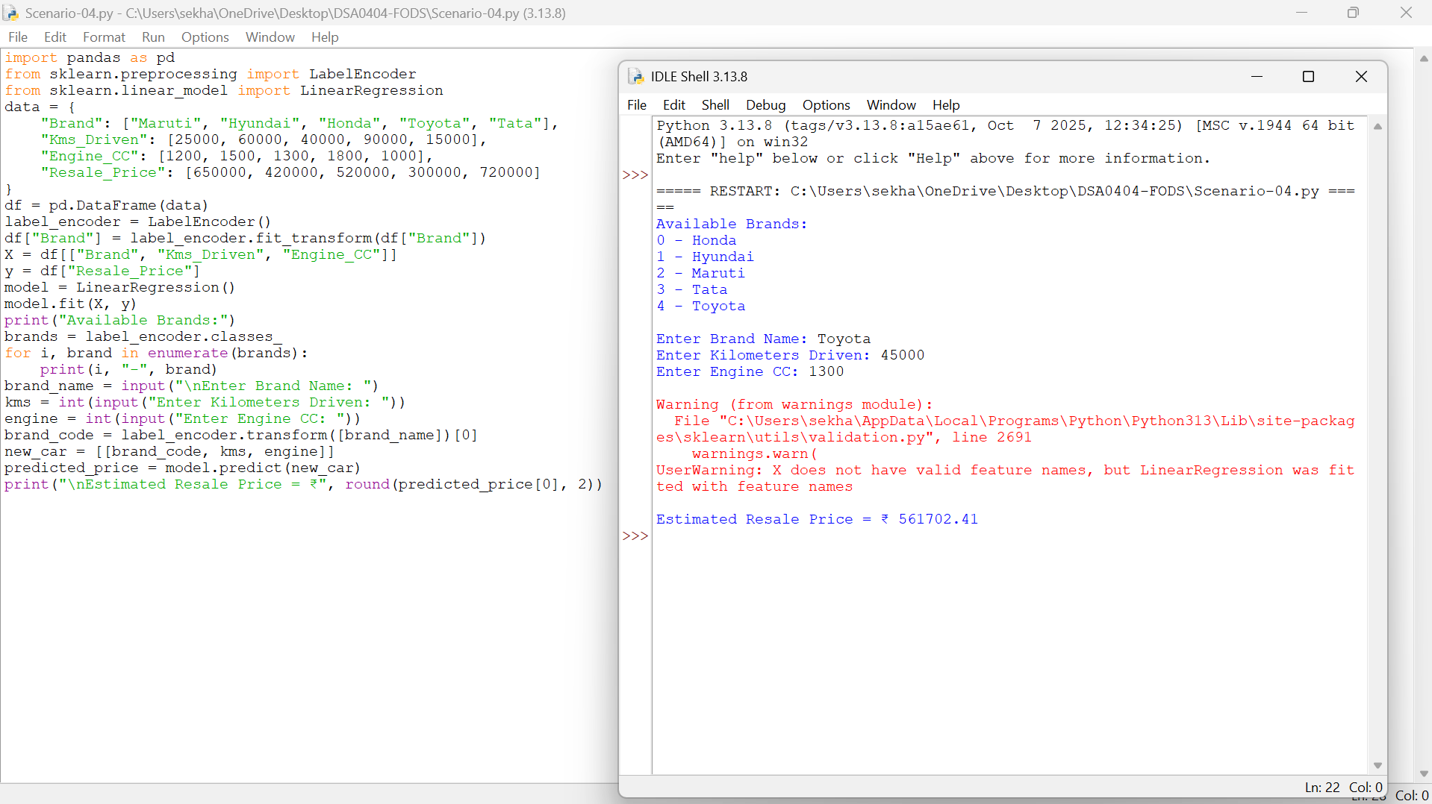

- Scenario: Loan Approval (CART Classification): A bank wants to decide whether to approve or reject a loan application. The decision depends on features like income, credit score, and existing loans. Past applications are labeled as Approved (1) or Rejected (0).
Question: Using CART, build a Decision Tree Classifier for loan approval.
Predict the class for a new applicant and display the decision rules.
Applicant_ID | Income (₹/Month) | Credit_Score | Existing_Loans | Approved
A1 | 45000 | 720 | 0 | 1
A2 | 30000 | 650 | 1 | 0
A3 | 60000 | 780 | 0 | 1
A4 | 28000 | 620 | 2 | 0
A5 | 52000 | 710 | 1 | 1
Ans:
Code:
import numpy as np
from sklearn.tree import DecisionTreeClassifier, export_text
X = np.array([
[45000, 720, 0],
[30000, 650, 1],
[60000, 780, 0],
[28000, 620, 2],
[52000, 710, 1]
])
y = np.array([1, 0, 1, 0, 1])
model = DecisionTreeClassifier(criterion="gini", random_state=42)
model.fit(X, y)
income = int(input("Enter Monthly Income: "))
credit = int(input("Enter Credit Score: "))
loans = int(input("Enter Existing Loans: "))
new_applicant = np.array([[income, credit, loans]])
prediction = model.predict(new_applicant)
print("\nPrediction Result")
if prediction[0] == 1:
print("Loan Approved")
else:
print("Loan Rejected")
feature_names = ["Income", "Credit_Score", "Existing_Loans"]
rules = export_text(model, feature_names=feature_names)
print("\nDecision Tree Rules:")
print(rules)
